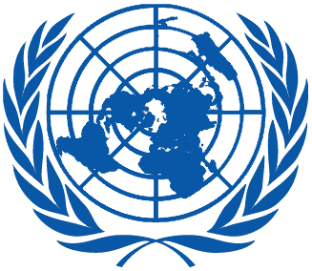 | Working Group on the Universal Periodic Review
Forty-sixth session
Geneva, 29 April–10 May 2024
Order of the Day
Plenary Meetings Room XX
Friday, 3 May 2024
MORNING
9:00 – 12:30  9th meeting |  | UPR of the Comoros  - National Report of the Comoros in accordance with paragraph 15 (a) of the annex to HRC resolution 5/1 and paragraph 5 of the annex to HRC resolution 16/21: A/HRC/WG.6/46/COM/1  - Compilation prepared by the OHCHR in accordance with paragraph 15 (b) of the annex to HRC resolution 5/1 and paragraph 5 of the annex to HRC resolution 16/21: A/HRC/WG.6/46/COM/2  - Summary prepared by the OHCHR in accordance with paragraph 15 (c) of the annex to HRC resolution 5/1 and paragraph 5 of the annex to HRC resolution 16/21: A/HRC/WG.6/46/COM/3
AFTERNOON
15:30 – 18:00  10th meeting |  | Adoption of the recommendations section on:
New Zealand
- Draft report of the UPR Working Group: A/HRC/57/4
Afghanistan
- Draft report of the UPR Working Group: A/HRC/57/5
Chile
- Draft report of the UPR Working Group: A/HRC/57/6
Cyprus
- Draft report of the UPR Working Group: A/HRC/57/7
Uruguay
- Draft report of the UPR Working Group: A/HRC/57/8
Notes:
All speakers scheduled to take the floor should upload the written version of their oral statements through the online system for inscription on the lists of speakers ( User Login (ohchr.org)) before the opening of the review.
- The full text of statements is available on UPR extranet page
- Conference/meeting participants should enter the Palais des Nations through Pregny Gate (Palais des Nations, 8-14 avenue de la Paix) from 8.00 a.m. to 5.00 p.m.
- PHOTOGRAPHS AND FILMING: Please note that only accredited media are permitted to film and take photographs in the room XX.

