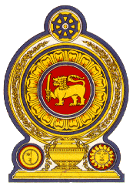

46th Session of the Universal Periodic Review

**Review of Cyprus** – 30th April 2024

Statement by the Democratic Socialist Republic of Sri Lanka

Mr. President,

Sri Lanka commends the delegation of Cyprus for the comprehensive presentation updating the progress and developments in promotion and protection of human rights in Cyprus since the last UPR cycle.

In a constructive spirit, Sri Lanka recommends that Cyprus;

1. Take further measures address and eliminate all forms of racial discrimination including xenophobia and hate speech through legislative and policy interventions.
2. Continue to take steps to uphold the rights to health and education of children from vulnerable segments in Cyprus in particular children with disabilities, minorities, and those from socioeconomically disadvantaged families.
3. Strengthen coordination with all stakeholders to comprehensively address gaps to combat trafficking in persons.

We wish Cyprus success in its UPR engagement.