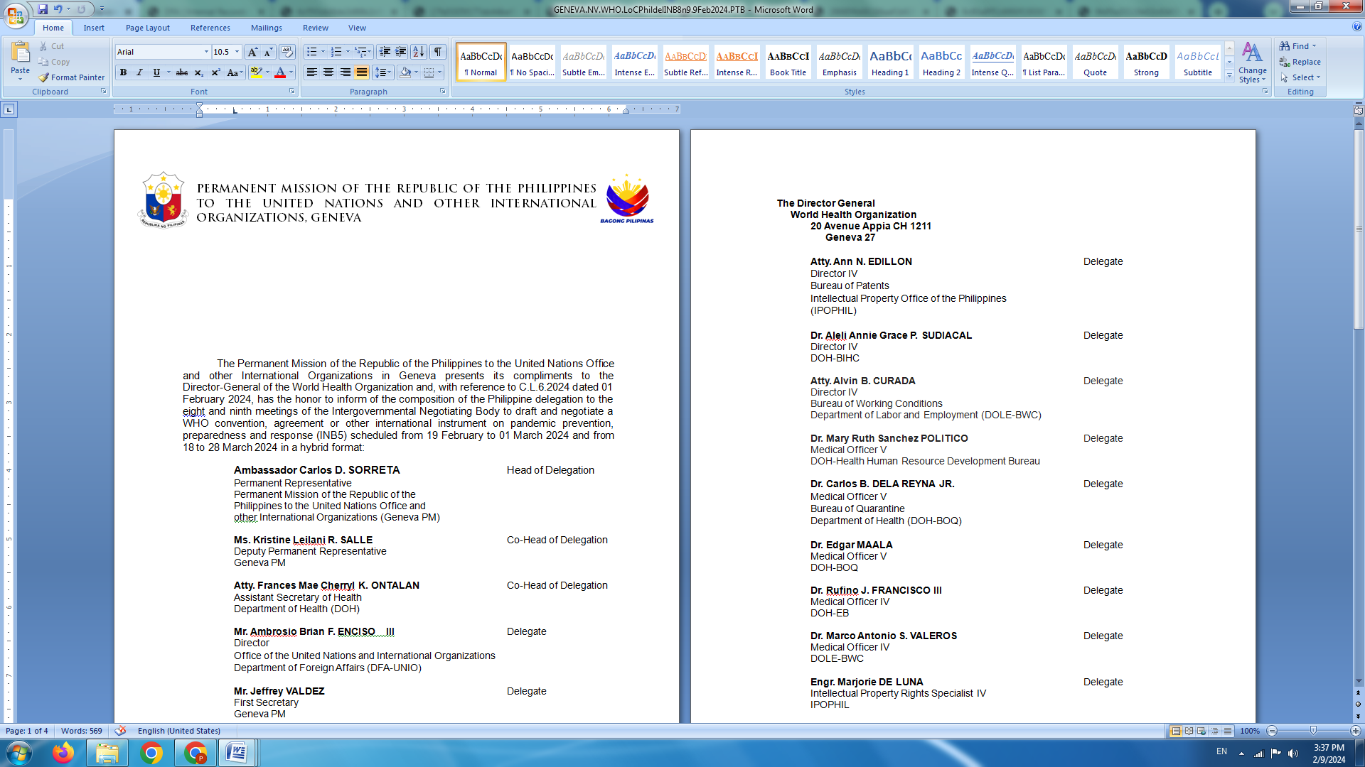

**P H I L I P P I N E S**

**HUMAN RIGHTS COUNCIL**

**46th Session of the Working Group on the Universal Periodic Review**

30 April 2024, Palais des Nations, Geneva, Switzerland

**UNIVERSAL PERIODIC REVIEW OF CYPRUS**

*To be delivered by*

**KRISTINE LEILANI SALLE**

**Ambassador and Deputy Permanent Representative**

*Speaking time: 1 minute 15 second*

We welcome the distinguished delegation of Cyprus and are pleased to note the significant steps taken during the review period to mainstream gender equality and combat violence against women and girls.

We also laud the revised Strategy for the Employment of Foreign Workforce and ratification of the Domestic Workers Convention.

To build on the gains achieved, we recommend that Cyprus:

1. Further strengthen its migration governance framework, including by adopting the Action Plan 2024-2026 on the integration and social inclusion of migrants and ensuring that alleged cases of pushbacks and ill-treatment of migrants are properly and promptly investigated;
2. Enhance human rights education and training for law enforcement on combatting racism, xenophobia and hate speech, including countering racial profiling; and
3. Bolster measures against the trafficking of women and girls for sexual and labour exploitation by improving mechanisms for the early detection of potential victims, especially among migrants and asylum-seekers, among others.

We wish Cyprus a successful review. **END**