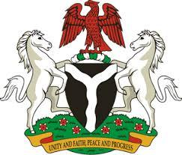

*Please check against delivery*

**HUMAN RIGHTS COUNCIL**

**46TH SESSION OF THE WORKING GROUP OF THE UPR**

**REVIEW OF THE REPUBLIC CYPRUS**

**30TH APRIL, 2024**

**STATEMENT BY NIGERIA**

**Mr. President,**

Nigeria welcomes the delegation of the Republic of Cyprus to the presentation of its National Report for the Fourth UPR Cycle and commends the Government for its commitment to international human rights obligations and human rights mechanisms.

2. Nigeria acknowledges the commitment of the Government of Cyprus to uphold human rights, particularly its efforts to protect the rights of migrants and combat human trafficking, including through the implementation of the National Action Plan 2023-2026 to combat trafficking in persons.

3. In the spirit of constructive dialogue, Nigeria wishes to recommend to Cyprus as follows:

1. To sustain its ongoing efforts to reduce gender pay gap between men and women;
2. To consider further necessary measures to ensure the protection of the rights of migrants and refugees, including through the ratification of the Convention on the Protection of the Rights of all Migrant Workers and Members of their Families;
3. To continue with its efforts to prevent and combat human trafficking.

4. We wish Cyprus a very successful review process.

I thank you, Mr. President.