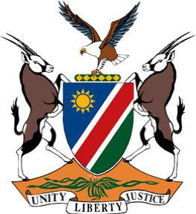

**Statement by Namibia at the 46th Session of the UPR Working Group:**

**Review of Cyprus, 30 April 2024**

**Mr. Vice-President,**

1. Namibia wishes the distinguished delegation of Cyprus a successful fourth review.
2. We commend the Government of the Republic of Cyprus for taking measures to uphold the protection and promotion of human rights and in the spirit of constructive dialogue and engagement, we wish to make the following two recommendations:
3. **First,** take further steps to combat the prevalence of trafficking in persons through full and effective implemention of the 2023-2026 National Action Plan. And
4. **Second,** intensify efforts to bring about equality between men and women in all spheres of society, including in decision-making positions.

**Thank you!**