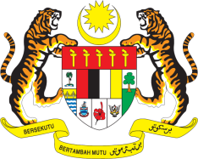

**STATEMENT BY MALAYSIA**

**REVIEW OF CYPRUS**

**46TH SESSION OF THE UPR WORKING GROUP**

**29 APRIL – 10 MAY 2024**

Malaysia thanks Cyprus for the presentation of its national report.

2. We commend Cyprus for its commitment to addressing gender equality and promoting women’s rights, combatting violence against women and young girls and countering gender discrimination. We welcome Cyprus’ efforts to promote dialogue, protect diversity and promote cultural identity of different religious groups.

3. In the spirit of constructive engagement, Malaysia recommends the following:

3.1 First, combat violence against women and domestic violence by providing adequate technical, human, and financial resources, to the proposed structure of the National Coordinating Body;

3.2 Second, establish a comprehensive monitoring system to combat discrimination, hate speech and other related intolerance against minority and vulnerable groups; and

3.3 Third, undertake full, effective and timely implementation of the National Biodiversity Strategy and Action Plan (NBSAP) to address all challenges associated with nature and biodiversity loss.

4. We wish Cyprus a successful review.

Thank you.

**30 APRIL 2024**

**GENEVA**