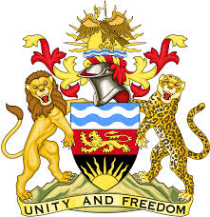

**REPUBLIC OF MALAWI**

**MALAWI STATEMENT ON CYPRUS UNIVERSAL PERIODIC REVIEW**

**TUESDAY, 30TH APRIL 2024**

**Mr. President**,

Malawi welcomes Cyprus to this review and thanks the delegation for the comprehensive presentation.

In the spirit of constructive dialogue, Malawi makes the following recommendations:

1. Continue with consultations and all necessary procedures towards the ratification of International Convention for the Protection of All Persons from Enforced Disappearance.
2. Continue taking all steps to combat racism and hate speech.
3. Continue with efforts to end gender-based violence and domestic violence.

.

We wish the Cyprus all the best at this review and in the implementation of the recommendations.

**Thank you, Mr. President**.