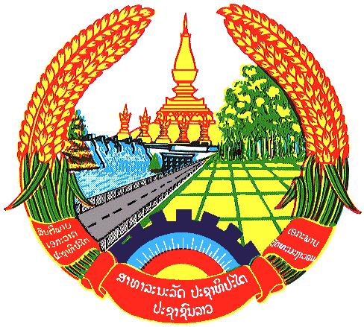

**Statement by the delegation of the Permanent Mission of the Lao PDR to the United Nations Office and other International Organizations in Geneva**

**at the 46th Session of UPR Working Group**

**Geneva, 30 April 2024**

(Speaking time 1.15 minute)

Review of Cyprus (14:30 - 18:00)

1. Thank you, Mr. President.
2. My delegation warmly welcomes the delegation of Cyprus and thanks for the presentation of the national report.
3. The Lao PDR commends significant progress made by Cyprus in the advancement of gender equality by taking steps and measures to promote women’s rights, including their equal participation in public and political life and equal pay between women and men.
4. In this constructive engagement, the Lao PDR recommends Cyprus the followings:

**ONE:** Strengthen efforts to fully implement the National Strategy on Equality between Women and Men 2024-2026; and

**TWO:** Continue to make progress on eradication of violence against women in the country.

1. We wish Cyprus a successful UPR review.
2. I thank you, Mr. President.