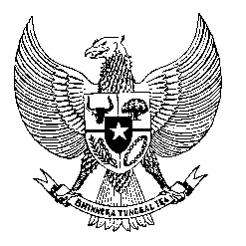

Permanent Mission

of the Republic of Indonesia to the UN, WTO,

and Other International Organizations

in Geneva

**STATEMENT BY THE DELEGATION OF THE REPUBLIC OF INDONESIA**

**AT THE 46th SESSION OF THE UPR WORKING GROUP**

**CONSIDERATION OF THE UPR REPORT OF CYPRUS**

**30 APRIL 2024**

**Mr. Vice-President**

* We warmly welcome the delegation of Cyprus and thank them for presenting the report.
* We commend Cyprus’ efforts to strengthen the protection of human rights, especially women, children, persons with disabilities and migrant workers, through the adoption of relevant national policy frameworks.
* In a constructive spirit, Indonesia offers Cyprus the following recommendations:
  1. Ratify the International Convention on the Protection of the Rights of All Migrant Workers and Members of Their Families.
  2. Effectively implement the 2024-2026 Strategy on Equality between Women and Men to further advance and mainstream gender equality across sectors of life.
  3. Ensure allocation of sufficient resources to tackle gender-based and domestic violence while protecting the victims’ rights.
  4. Strengthen efforts to guarantee equal access to health-care and social welfare services for all without discrimination.
* Finally, we wish Cyprus a successful UPR.
* Thank you.

*Word counts: 142.*

*Time limit: 1 minute 15 seconds.*