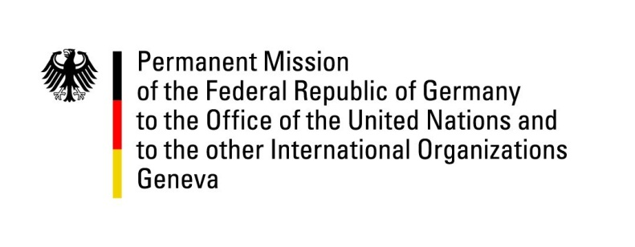

**United Nations Human Rights Council**

**46th Session of the UPR Working Group**

**Geneva, 30th of April 2024**

**German Recommendations and advance questions to**

**Cyprus**

Mister President,

Germany welcomes the delegation of the Republic of Cyprus.

We commend Cyprus for its high standard in human rights protection and the promotion of human rights. We especially commend the determination of the Republic of Cyprus to revise criteria for the nationality of the Republic of Cyprus in the best interests of the children of mixed marriages, and to apply the new criteria to all children, whatever the parent’s nationality, in such a way as to avoid precarious legal positions of the prospective applicants.

Additionally, Germany sees room for further strengthening human rights with regard to the conduct of criminal investigations, the state of media freedom and of association.

Germany therefore recommends to:

* conduct criminal investigations, in accordance with the principles of the rule of law in a speedy, concentrated, holistic, and comprehensive manner, and encourages Cyprus to considerably strengthen the right to a fair and public trial;
* legally guarantee the effective protection of journalists and their sources, and to prevent political interference in media work through appropriate legislative measures;
* strengthen the freedom of association of nongovernmental organizations and to review registration procedures accordingly.

Thank you, Mister President.

**GERMAN ADVANCE QUESTIONS TO CYPRUS:**

* What steps is Cyprus taking in order to strengthen the rule of law, i.e. with regard to making decisions to prosecute or not prosecute within a reasonable period of time, strengthening the right to a fair and public trial, or taking effective measures to accelerate the duration of civil, administrative and international protection (asylum) trials?
* What steps is Cyprus taking in order to strengthen media freedom, especially with regard to the protection of journalists and their sources, as well as the protection of journalists and media workers from political interference?
* What steps is Cyprus taking to respond to the communication of the Commissioner for Human Rights of the Council of Europe regarding the specific case of the nongovernmental organization “Movement for Equality, Support, Anti-Racism” (Kínisi gia Isótita, Stírixi, Antiracismó; KISA)? How does Cyprus plan to constructively take up the suggestion contained therein for strengthening the freedom of association of nongovernmental organizations?