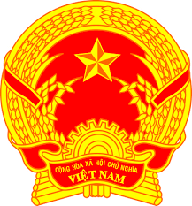

**Statement of the Socialist Republic of Viet Nam**

*46th Session of the UPR Working Group  
Review of Comoros*

*(Geneva, 03 May 2024)*

***Time: 01 minute and 20 seconds***

*Mister Vice-President,*

Viet Nam commends the delegation of Comoros for the comprehensive presentation of the national UPR report.

Viet Nam welcomes the commitment of Comoros to implementing the Sustainable Development Goals. Viet Nam also appreciates the efforts made by Comoros to promote and protect the rights of women, including measures taken to prevent and respond to violence against women.

In a spirit of constructive dialogue, Viet Nam would like to make the following two recommendations to Comoros:

1. Take further comprehensive measures to end early marriages.

2. Continue its efforts to promote sustainable economic and social development in order to facilitate the enjoyment of human rights of its people.

Viet Nam wishes Comoros a successful review.

*I thank you./.*