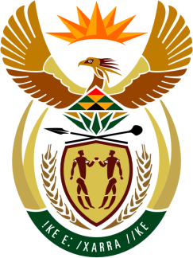

**SOUTH AFRICAN PERMANENT MISSION**

**TO THE UNITED NATIONS**

**AND OTHER INTERNATIONAL ORGANISATIONS**

**46th SESSION OF THE WORKING GROUP ON THE**

**UNIVERSAL PERIODIC REVIEW**

**Review of comoros**

**03 maY 2024**

**(1 MINUTE 20 Seconds)**

**speaker no: 35**

***Check against delivery***

**Mr. President,**

South Africa welcomes the distinguished delegation of Comoros to this UPR Session and wishes the country a successful review.

South Africa commends the Comoros for its efforts at improving the human rights situation in the country and welcomes the reform process aimed at giving effect to the provisions of the new, revised Constitution of 2018. We also welcome projects aimed at strengthening the institutional framework, the construction of democracy and the separation of powers in order to guarantee the rule of law in Comoros. My delegation also welcomes the implementation of the Emerging Comoros Plan (2020–2030).

South Africa wishes to make the following recommendations:

* + ensure that that the Comoros ratify the International Covenant on Civil and Political Rights and the International Covenant on Economic, Social and Cultural Rights;
  + encourage the Comoros to ratify the Optional Protocol to the Convention on the Rights of Persons with Disabilities;
  + encourage the Comoros ratify the Optional Protocol to the Convention on the Elimination of All Forms of Discrimination against Women;
  + put measures in place to ensure that the State respects the right to peaceful protest; and
  + Ensure that the Comoros step up its efforts to ensure children’s access to education without discrimination

**I thank you.**