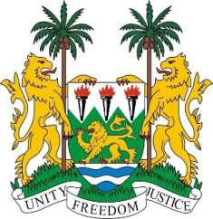

**SIERRA LEONE**

**46th Session of the UPR**

**REVIEW OF COMOROS**

Thursday, 3rd May 2024

**Check against delivery.**

Sierra Leone welcomes and thanks **H.E. Mr. Djae Ahamada, Minister of Justice, Islamic Affairs and Public Service in charge of Human Rights, Transparency and Public Administrations,** and the distinguished delegation from the Union of the Comoros for the presentation of its national report.

We welcome the commendable efforts of the Union of the Comoros to prioritise human rights, the rule of law and gender equality through initiatives such as the Emerging Comoros Plan (2020-2030).

We commend the unanimous parliamentary adoption of the law on the organisation of the judiciary, which aims to decentralise the judiciary, improve access to justice and strengthen the independence of the judiciary.

In order to ensure the effective implementation of its human rights obligations, we support increased assistance to the Union of the Comoros. This can be achieved through progressive technical and financial assistance aimed at facilitating the implementation of the country's human rights commitments and obligations.

In the spirit of constructive dialogue, Sierra Leone offers the following recommendations:

1. Implement measures to improve prison conditions, ensuring compliance with international standards.
2. Continue to take concrete steps, including legislation, to address gender-based violence and promote gender equality.
3. Implement measures to ensure access to education for vulnerable groups, in particular children in rural communities and those from underprivileged households.

Sierra Leone wishes the Union of the Comoros a successful fourth-cycle review.

**Thank you, Mr President**.