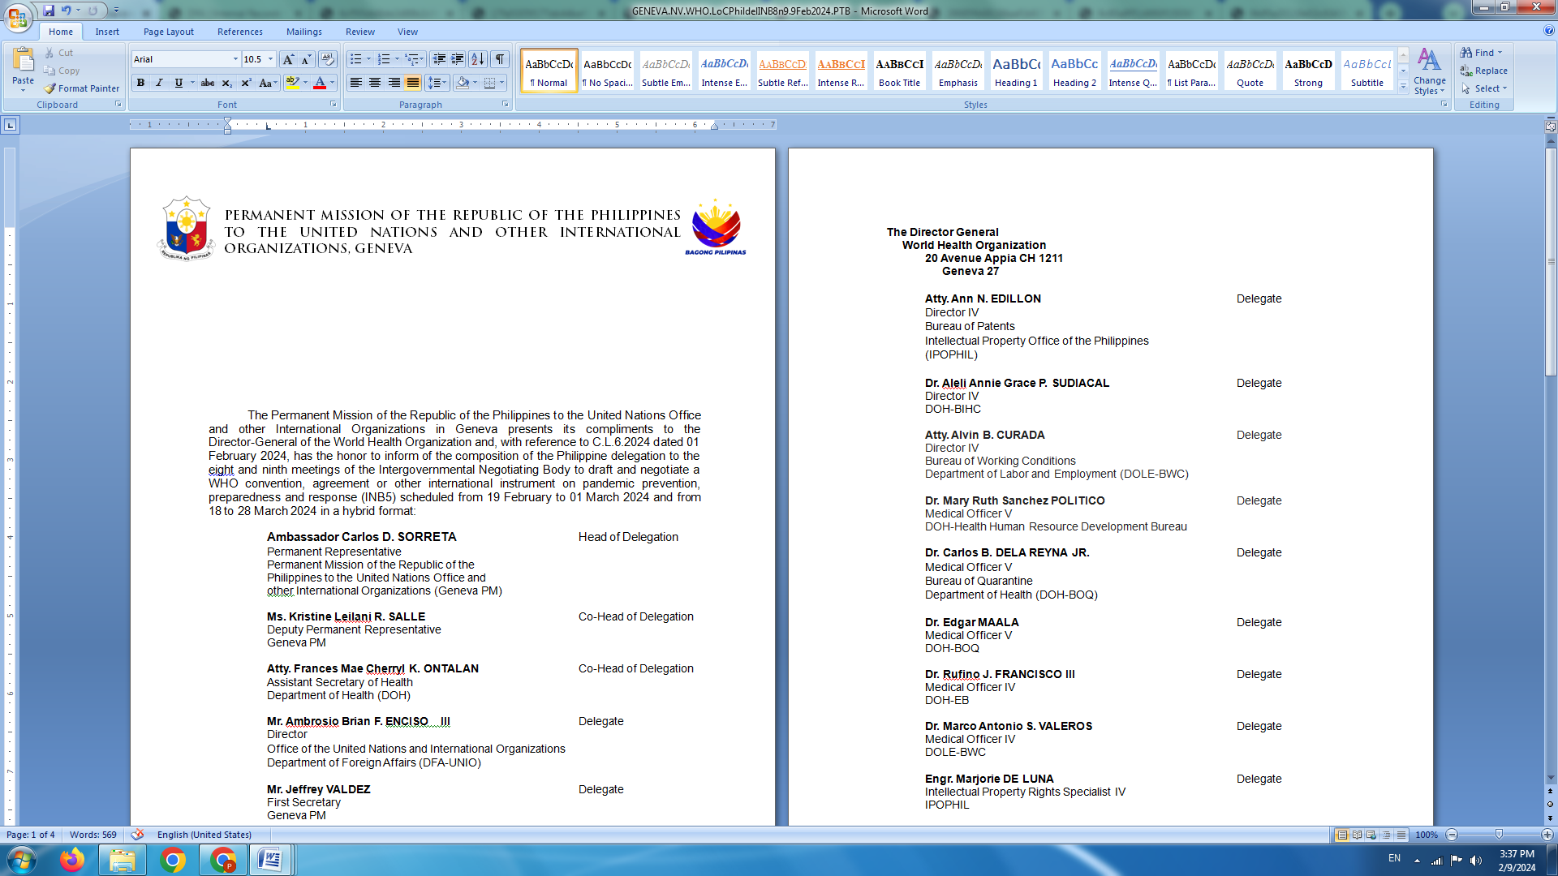

**P H I L I P P I N E S**

**HUMAN RIGHTS COUNCIL**

**46th Session of the Working Group on the Universal Periodic Review**

03 May 2024, Palais des Nations, Geneva, Switzerland

**UNIVERSAL PERIODIC REVIEW OF COMOROS**

*To be delivered by:*

**KRISTINE LEILANI R. SALLE**

**Deputy Permanent Representative**

*Speaking time: 1 minute 20 seconds*

The Philippines commends Comoros’ ratification of the International Convention on the Protection of the Rights of All Migrant Workers and Members of Their Families and ILO conventions that enhance protection norms and mechanisms of the rights of workers.

We also acknowledge the enactment in January 2021 of the framework law enshrining the right to education of every child as well as policy measures aimed at achieving climate resilience and environmental sustainability, especially in the maritime sector.

In the spirit of constructive dialogue, the Philippine offers the following recommendations:

1. Continue to allocate more resources to the education sector to improve school infrastructure and learning materials and enhance teacher training for quality and inclusive education for all;
2. Expedite the process of adopting the framework law on gender equality in order to effectively address gender-based violence and discrimination and foster an enabling environment for increased women participation in the country’s political and economic life.
3. Speed up work on the draft law and national action plan to prevent and combat human trafficking and migrant smuggling.

In closing, the Philippines wishes Comoros all success in this review. **END.**