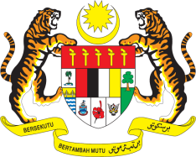

**STATEMENT BY MALAYSIA**

**REVIEW OF COMOROS**

**46TH SESSION OF THE UPR WORKING GROUP**

**29 APRIL – 10 MAY 2024**

Malaysia thanks Comoros for the presentation of its national report.

1. Malaysia commends Comoros on the development of policies and strategies such as the National Health Policy (2023–2030), which have helped to improve the quality of healthcare professionals and facilities nationwide.
2. In the spirit of constructive engagement, Malaysia recommends the following:
   1. First, enhance access to free, quality basic education, particularly for marginalised groups such as impoverished children and persons with disabilities;
   2. Second, enhance healthcare accessibility in rural areas through mobile health clinics and capacity-building initiatives for healthcare professionals; and
   3. Third, strengthen legislative measures that protect women from violence and discrimination, as well as promote women’s equal participation in all social and economic aspects.
3. We wish Comoros a successful review.

Thank you.

**3 MAY 2024**

**GENEVA**