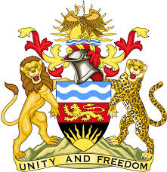

**REPUBLIC OF MALAWI**

**MALAWI STATEMENT ON COMOROS UNIVERSAL PERIODIC REVIEW**

**FRIDAY, 3RD MAY 2024**

**Mr. President**,

Malawi welcomes Comoros to this review and thanks the delegation for the comprehensive presentation.

In the spirit of constructive dialogue, Malawi makes the following recommendations:

1. Continue with all efforts to fully implement the Emerging Comoros Plan (2020–2030)
2. Continue with all efforts to end violence against women and girls.

We wish Comoros all the best at this review and in the implementation of the recommendations.

**Thank you, Mr. President**.