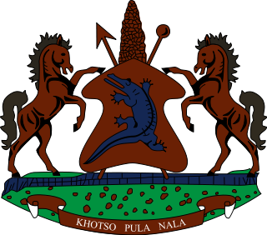

**INTERVENTION OF THE DELEGATION OF LESOTHO UNDER THE UPR REVIEW OF COMOROS**

**03 MAY 2024**

**GENEVA, SWITZERLAND**

**Thank you Mr. President,**

My delegation welcomes the distinguished delegation of Comoros to the Working Group and thank them for the presentation of their Report. We take cognisance of the strides taken by the Government to inculcate the respect for human rights in the country. Lesotho notes with appreciation the steps taken to bring the National Commission on Human Rights and Freedoms more in line with the Paris Principles. We applaud Comoros for establishing an Inter-ministerial Reporting and Follow-up Committee to address the backlog of overdue reports to the treaty bodies.

Lesotho seizes this opportunity to offer the following recommendations to the Government of Comoros; 1. To ratify ICCPR and ICESCR; 2. To beef up measures to address trafficking in persons and ensure that appropriate sentences are accorded to perpetrators of this heinous crime, lastly, to undertake measures to curb violence

against women and intensify efforts to raise awareness about how women and girl victims of violence can access justice.

We wish to conclude by wishing the Government of Comoros a successful review.

**THANK YOU**