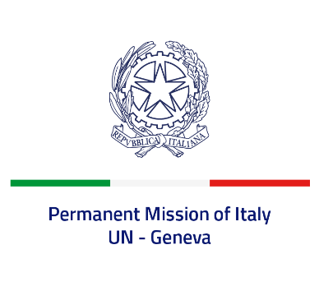

*Check against delivery*

**UPR 46 – Comoros**

**Friday 3 May 2024, 9:00 – 12:30**

**Delivered by: Permanent Representative of Italy Amb. Vincenzo Grassi**

Thank you, Mister President.

We thank the distinguished delegation of the Comoros for their national report and presentation.

Italy welcomes the progress made since the last cycle and the efforts to improve the protection of human rights at national level, including with regard to the fight against human trafficking.

Italy would like to recommend to:

* *Complete the ratification process for the International Covenant on Civil and Political Rights and the International Covenant on Economic, Social and Cultural Rights and sign and ratify the Convention on the Elimination of All Forms of Discrimination against Women;*
* *Protect and promote the rights to freedom of expression, association and peaceful assembly;*
* *Reduce overcrowding in prisons and ensure safe and humane detention conditions for all inmates;*
* *Take further measures to protect the rights of women and children in order to combat all forms of violence, discrimination and exploitation, including sexual violence and child labour;*
* *Abolish legal provisions criminalizing homosexuality;*
* *Intensify efforts towards the de jure and complete abolition of the death penalty.*

We wish the delegation of the Comoros a successful review.

*I thank you.*