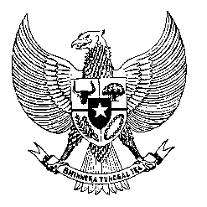

Permanent Mission
of the Republic of Indonesia to the UN, WTO,
and Other International Organizations
in Geneva

STATEMENT BY THE DELEGATION OF THE REPUBLIC OF INDONESIA
AT THE 46th SESSION OF THE UPR WORKING GROUP
CONSIDERATION OF THE UPR REPORT OF COMOROS
3 MAY 2024

Mr. Vice President,

We thank the esteemed delegation of the Union of the Comoros for presenting its national report.

Indonesia appreciates the continuous efforts to improve the legal and policy frameworks related to human rights, including the reform process to strengthen democracy and the rule of law.

We also note Comoros' commitment to undertaking the ratification process for all unratified international human rights instruments.

While acknowledging these efforts, Indonesia recommends the following actions:

- Enhance torture prevention through law enforcement training focused on avoiding torture and ill-treatment;
- Develop and implement health policies to achieve universal health coverage, with particular focus on maternal, neonatal, and child health;
- Expand social protection to cover a larger portion of the population, particularly those under the national poverty line and those facing severe food insecurity.

We wish the Union of the Comoros a successful review.

Thank you.

