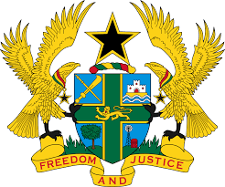

**STATEMENT DELIVERED BY GHANA DURING THE 46TH SESSION**

**OF THE UPR WORKING GROUP, ON FRIDAY 3RD MAY, 2024**

**UNIVERSAL PERIODIC REVIEW OF COMOROS**

Mr. Vice President.

2. Ghana commends the authorities of the Union of the Comoros for the substantial progress it has made in the implementation of the 165 recommendations accepted from the third UPR cycle in 2019.

3. We particularly acknowledge the setting up of the Anti-Corruption Chamber in the Supreme Court, which is a clear demonstration of a commitment by the Union of the Comoros to combat corruption in all its forms and to tackle impunity head on. We further welcome the adoption of the National Climate Change Resilience Strategy, the implementation of which could help mitigate the climate hazards that Comoros is exposed to.

4. Ghana offers the following recommendations in the spirit of constructive dialogue:

1. Ratify the Optional Protocol to the Convention on the Elimination of All Forms of Discrimination against Women;
2. Intensify efforts to ensure that children have equal access to health care and education without discrimination; and
3. Design a national policy to promote equality in employment and occupation for all categories of the population.

5. Ghana wishes the Union of the Comoros success in the review process.

I thank you.