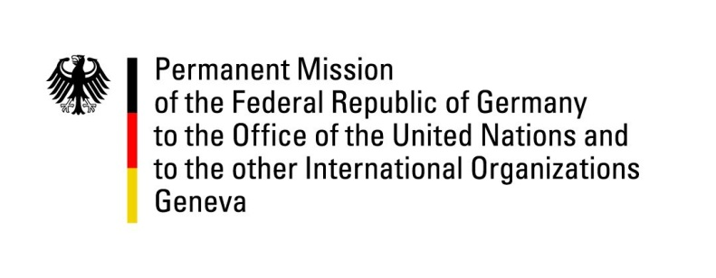

**United Nations Human Rights Council**

**46th Session of the UPR Working Group**

**Geneva, 3rd of May 2023**

**German Recommendations to**

**Comoros**

Mister President,

Germany welcomes the delegation of the Comoros.

Germany commends the Comoros for appointing members of the National Commission for Human Rights and for working towards the improvement in applying the law forbidding violence against women by training staff in the judiciary. Germany welcomes that the government is also striving to fill more public positions with women.

However, Germany remains generally concerned by the restrictions of civil and political rights, which have unfortunately been observed specifically during and after the presidential election in January 2024. Germany is also concerned about the lack of implementation of recommendations since the last UPR cycle. We are further worried about the situation of women and girls, especially with regards to sexual and gender-based violence, the conditions in prisons, and the situation of migrants and refugees.

Germany therefore recommends to:

* Ratify the Second Optional Protocol to the International Covenant on Civil and Political Rights, as supported by the Comoros in the last UPR cycle;
* Improve access to justice and prison conditions, inter alia by improving allocations for detainees in the budget of the Ministry of the Judiciary;
* Decriminalize same-sex relationships between consenting adults;
* Ratify the Optional Protocol to Convention on the Elimination of All Forms of Discrimination against Women.

Thank you, Mister President.