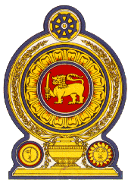

46th Session of the Universal Periodic Review

**Review of Chile**– 30th April 2024

Statement by the Democratic Socialist Republic of Sri Lanka

Mr. President,

Sri Lanka welcomes the delegation of Chile and appreciates the presentation made.

Sri Lanka commends the measures taken by Chile to facilitate a number of visits by special procedure mandate holders and the submission of timely treaty body reports since its last UPR.

In a constructive spirit, Sri Lanka recommends that Chile;

1. Continues to strengthen anti-discrimination legislation and increase protection for vulnerable groups such as indigenous people, migrants and women.
2. Promote respect for diversity, multiculturalism and non-discrimination.
3. Strengthen efforts to prevent and investigate human smuggling and trafficking.
4. Address challenges with regard to the proper identification of situations of trafficking, especially child trafficking.
5. Take measures to allocate adequate resources and experts for the implementation of the National Truth and Justice Plan.

We wish Chile success in its UPR engagement.