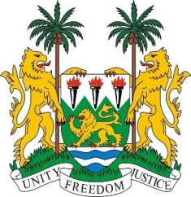

**SIERRA LEONE**

**46th Session of the UPR**

**REVIEW OF CHILE**

Tuesday, 30th APRIL 2024

**Check against delivery.**

**Mr. President**,

Sierra Leone welcomes and thanks **H.E. Luis Cordero Vega, Minister of Justice and Human Rights** and the distinguished delegation from Chile for the presentation of its national report.

While Chile's ratification of several treaties was noted in the third review cycle, we commend their recent ratification of key instruments such as the Convention on the Elimination of All Forms of Discrimination Against Women (CEDAW) and the Protocol to the Forced Labour Convention.The establishment of the National Climate Change Adaptation Plan 2024-2029 is also commendable and demonstrates Chile's commitment to addressing environmental challenges.

We also welcome the adoption of progressive legislation on investigation and accountability, as exemplified by Laws 21, 427 of 2022 and Law 638 of 2023. The establishment of the National Plan for the Search for Missing Persons from the Civilian-Military Dictatorship reflects Chile's commitment to addressing historical injustices. We also commend the jurisprudence of the Supreme Court, which reaffirmed that war crimes and crimes against humanity are not subject to any statute of limitations in Chile. In addition, we recognise the government's efforts to address reparations, as evidenced by its response to the Inter-American Court of Human Rights case Ordenes Guerra Et Al v Chile.

While acknowledging the progressive reforms aimed at improving gender equality, we offer the following recommendations to address existing gaps:

1. Accelerate the adoption of gender quotas for regional governors and councilors, with a particular focus on the inclusion of indigenous women in mainstream politics.
2. Consider legislation to promote equality in employment and establish quotas for women in the private sector, coupled with measures to improve their access to financial support.

Sierra Leone wishes Chile every success in completing its fourth review cycle.

**Thank you, Mr. President.**