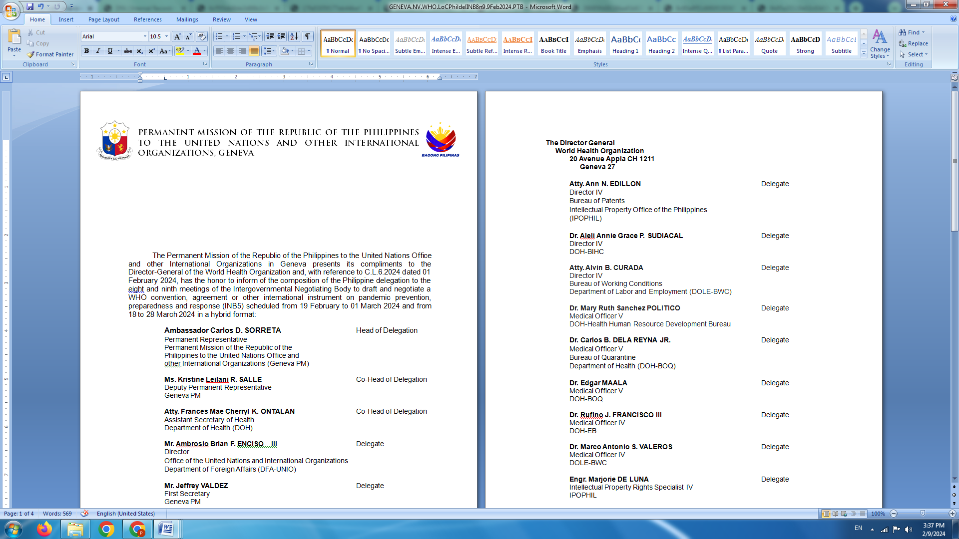

**P H I L I P P I N E S**

**HUMAN RIGHTS COUNCIL**

**46th Session of the Working Group on the Universal Periodic Review**

30 April 2024, Palais des Nations, Geneva, Switzerland

**UNIVERSAL PERIODIC REVIEW OF CHILE**

**REVIEW OF CHILE**

**30 April 2024**

*Delivered by*

**First Secretary Lunigning Camoying Valdez**

*Speaking time: 1 minute*

The Philippines welcomes the esteemed delegation of Chile.

We recognize Chile’s recent efforts to strengthen democratic institutions and advance accountability for past human rights violations, including enforced disappearances.

We commend Chile for its robust Framework Act on Climate Change which incorporates gender equity considerations.

In the spirit of constructive dialogue, the Philippines recommends that Chile:

1. Further enhance human rights training and education for law enforcement officers to inculcate maximum tolerance and other human rights-based approaches to handling social protests;
2. Expedite work on the draft comprehensive legislation on combatting and preventing violence against women; and
3. Strengthen mechanisms for the protection of migrants and refugees, including by upholding the principle of non-refoulement and effective implementation of the 2021 migration law and 2023 National Migration Policy.

We wish Chile a successful review. **END**