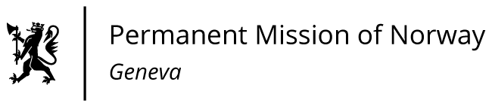

**STATEMENT**

**UPR 46 Session of the Human Rights Council**

**on the human rights situation in Chile,**

**as delivered by Mr. Martin TORBERGSEN**

**Minister Counsellor, Permanent Representative of Norway in Geneva.**

Check against delivery

30 April 2024

President,

Norway warmly welcomes Chile's delegation and engagement in the UPR process. We commend Chile for important progress to strengthen the protection of human rights, including the national plan for victims of enforced disappearances during the dictatorship, as well as the recent bill on gender-based violence.

Norway recommends that Chile:

1. Eliminate all barriers that hinder access to abortion in cases prescribed by law.

2. Enhance the consultations with the indigenous peoples concerned in order to obtain their free, prior and informed consent in accordance with ILO Convention 169.

3. Prevent excessive use of force during law enforcement operations and ensure accountability at all levels to avoid impunity.

4. Establish effective policies, with sufficient resources, to implement the Bill against gender-based violence.

Thank you