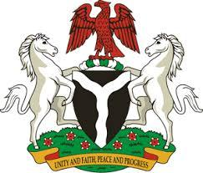

*Please check against delivery*

**HUMAN RIGHTS COUNCIL**

**46TH SESSION OF THE WORKING GROUP OF THE UPR**

**REVIEW OF CHILE**

**30TH APRIL, 2024**

**STATEMENT BY NIGERIA**

**Mr. President,**

Nigeria welcomes the delegation of Chile to the presentation of its National Report for the Fourth UPR Cycle and commends the Government for its commitment to international human rights obligations and human rights mechanisms.

2. Nigeria commends the Government of Chile for measures adopted to advance the economic and social rights of its citizens. In particular, Nigeria acknowledges the commitment of Chile to poverty alleviation through implementation of social programmes, as well as its strides to improve access to education and healthcare for its citizens.

3. In the spirit of constructive dialogue, Nigeria wishes to recommend to Chile as follows:

1. To enhance its legal system and strengthen judicial safeguards for the promotion and protection of human rights of all;
2. To scale up its efforts to ensure the promotion and protection of the rights of migrants; including by commitment to the principle of non-refoulment; and
3. To continue with its strident efforts to combat human trafficking.

4. We wish Chile a very successful review process.

I thank you, Mr. President.