*Check against delivery*

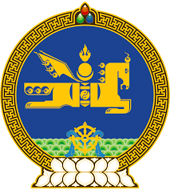

**46th SESSION OF THE UPR WORKING GROUP**

**MONGOLIA’S STATEMENT AT THE REVIEW OF CHILE**

**30 April 2024, 09:00 - 12:00 hrs**

(1 min)

Thank you, Mr. President.

Mongolia warmly welcomes the delegation of Chile to its 4th UPR review.

Mongolia commends Chile’s continued efforts and the progress made in strengthening the legislative and institutional framework and promoting human rights education. We take positive note of the measures aimed at closing the digital divide as well as protecting personal privacy.

My delegation further welcome Chile’s ratification of the Optional Protocol to the Convention on the Elimination of All Forms of Discrimination against Women.

Mongolia seizes this opportunity to recommend Chile to continue its efforts to address all forms of violence against women and take necessary measures to strengthen its support and rehabilitation centers and other first response initiatives.

We wish the delegation of Chile fruitful deliberations.

I thank you.

---oOo---