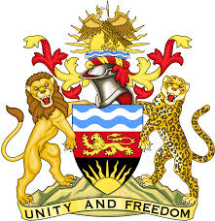

**REPUBLIC OF MALAWI**

**MALAWI STATEMENT ON CHILE UNIVERSAL PERIODIC REVIEW**

**TUESDAY, 30TH APRIL 2024**

**Mr. President**,

Malawi welcomes Chile to this review and thanks the delegation for the comprehensive presentation.

In the spirit of constructive dialogue, Malawi makes the following recommendations:

1. Continue taking all measures to protect the rights of older persons
2. Take steps to ensure the recognition, representation and participation of Indigenous Peoples

.

We wish the Chile all the best at this review and in the implementation of the recommendations.

**Thank you, Mr. President**.