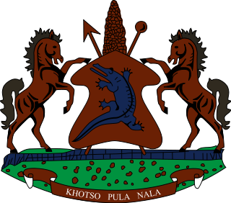

**INTERVENTION OF THE DELEGATION OF LESOTHO UNDER THE UPR REVIEW OF CHILE**

**30 APRIL 2024**

**GENEVA, SWITZERLAND**

**Thank you Mr. President,**

We welcome the delegation of Chile to the UPR Working Group and thank them for the presentation of their National Report. We recognise their commitment to the promotion of human rights in the country, as well as within the Council. Lesotho welcomes the adoption of anti-discrimination legislation aimed at enhancing women, children and Indigenous Peoples’s rights. We applaud Chile for extending standing invitations to the special procedures and mandate holders of the Office of the High Commissioner for Human Rights.

Lesotho seizes this opportunity to offer the following reccomendaions to the Government of Chile; 1. To beef up measures to sageguard freedom of expression and opinion, by all, at all times; 2. To accelerate efforts to mitigate incidents of excessive use of force and ill-treatment of detainees, by law enforcement agencies and, 3. to undertake measures to curb overcrowding in detention centers by offering alternative sentences for minor offences.

We wish to conclude by wishing the Government of Chile a successful review.

**THANK YOU**