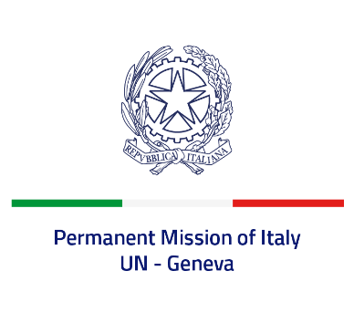

*Check against delivery*

**UPR 46 - Chile**

**Tuesday 30 April 2024, 9:00 - 12:30**

**Delivered by: Minister Stefano Pisotti, Deputy Permanent Representative of Italy**

Thank you, Mister President.

We thank the distinguished delegation of Chile for the presentation.

Italy commends Chile’s commitment to promoting human rights globally, also as a current member of the Human Rights Council.

We particularly welcome the adoption of the second National Human Rights Plan in 2022 and the ratification of the Optional Protocol to the CEDAW Convention in 2020.

Italy seizes this opportunity to offer Chile the following recommendations:

* *Continue efforts to prevent and combat violence against women and to protect victims;*
* *Strengthen the promotion of Indigenous Peoples’ rights, including through consultation mechanisms and the revision of the counter-terrorism legislation;*
* *Move forward with police reform in order to advance efficiency, transparency and a gender- and human rights-based approach to policing;*
* *Consider repealing the “Amnesty Law”.*

We wish Chile a successful review.

I thank you.