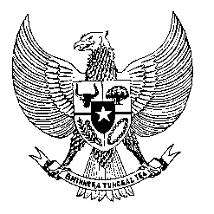

Permanent Mission

of the Republic of Indonesia to the UN, WTO,

and Other International Organizations

in Geneva

**STATEMENT BY THE DELEGATION OF THE REPUBLIC OF INDONESIA**

**AT THE 46th SESSION OF THE UPR WORKING GROUP**

**CONSIDERATION OF THE UPR REPORT OF CHILE**

**30 APRIL 2024**

**Madame Vice-President**

* Indonesia welcomes the delegation of Chile and thanks them for presenting their national report.
* We appreciate the launch of the Framework of Act of Climate Change in 2022 and the National Climate Change Adaptation Plan 2024–2029.
* In that regard, Indonesia recommends that Chile:
  1. Enhance efforts to strengthen the quality, access, and affordability of education and health services as well as employment opportunity for persons with disabilities.
  2. Continue to implement the Chile Framework Act on Climate Change in order to address the importance of a healthy and sustainable environment for the enjoyment of human rights.
  3. Develop measures to eliminate xenophobia and discriminatory stereotypes in respect of migrant workers and members of their families.
* To conclude, we wish Chile a successful review.
* Thank you.