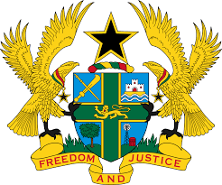

**STATEMENT DELIVERED BY GHANA DURING THE 46TH SESSION**

**OF THE UPR WORKING GROUP ON TUESDAY, 30TH APRIL, 2024**

**UNIVERSAL PERIODIC REVIEW OF CHILE**

Madam Vice President,

Ghana welcomes the delegation of Chile and commends its continued cooperation with human rights mechanisms.

2. We applaud the efforts by the Government of Chile to improve rural education outcomes through child-focused programmes such as the CREA Rural platform, which is aimed at providing rural schools with quality learning opportunities.

3. In the spirit of constructive engagement, Ghana makes the following three (3) recommendations:

* Ensure that the bill on women’s right to a life free of violence becomes law;
* Strengthen national strategies to address the high and increasing use of drugs, alcohol and tobacco among young people; and
* Ensure the vigorous enforcement of anti-discrimination legislation.

4. Ghana wishes Chile a very successful review process.

I thank you.