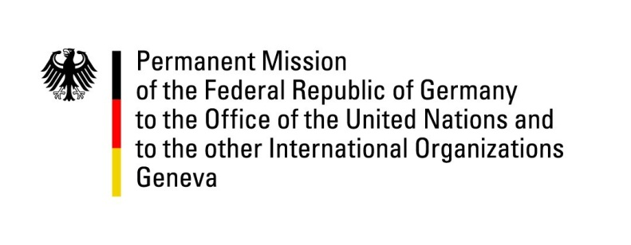

**United Nations Human Rights Council**

**46th Session of the UPR Working Group**

**Geneva, 30 of April 2024**

**German Recommendations and advance questions to**

**Chile**

Mister President,

Germany welcomes the delegation of Chile.

Germany commends Chile for its strong efforts in protecting and promoting human rights and for important advances in the reporting period, including with respect to the rights of women and queer persons and in relation to environmental and climate protection.

However, Germany remains concerned about remaining challenges in these areas, with respect to indigenous communities and accountability for excessive police violence during the 2019 protests.

Germany therefore recommends to:

* Continue to take substantial steps to eliminate discrimination against indigenous groups and guarantee their rights, including by ensuring appropriate representation in the political process.
* Continue the institutional modernization of the police forces (Carabineros de Chile), including by adopting the bill establishing general rules on the use of force by security agents
* Expedite judicial processes to ensure accountability for the cases of excessive violence in the 2019 protests.

Thank you, Mister President.