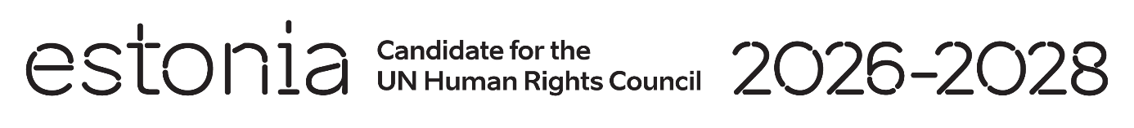

**Universal Periodic Review of Chile**

**30 April 2024**

**Intervention by the delegation of Estonia**

Estonia welcomes the delegation of Chile to its fourth UPR. We thank Chile for its national report and the information provided today. We would also like to commend Chile’s active and constructive role as a member in the Human Rights Council.

Estonia commends Chile for legalizing same-sex marriage and for increasing the legal age of marriage to 18 without exception. We also take positive note of the advancements in ensuring freedom of opinion and expression and the progress towards an inclusive education system.

We would like to recommend to Chile to:

* adopt legislation to explicitly prohibit and prevent corporal punishment of children and adolescents;
* facilitate access to support services for gender-based violence that are geographically close and culturally appropriate to rural and indigenous women;
* decriminalize defamation in accordance with international standards.

Estonia wishes to the delegation of Chile a successful review.

Thank you.