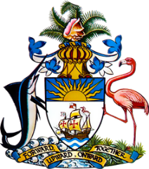

Statement by H.E. Ms. Patricia A. Hermanns, Ambassador/Permanent Representative
Permanent Mission of The Bahamas to the United Nations Office and Other International Organizations in Geneva
at the 46th Session of the Universal Periodic Review Working Group
Presentation of National Report by the Government of Chile
30 April 2024

Thank you, Mr./Madam [Vice] President.
We congratulate Chile for its steadfast efforts to promote human rights, including by electing the world’s first gender-equal constitutional assembly, which helped to set a global standard. We also welcome the acceptance, by Chile, of all recommendations made by The Bahamas during the last review and progress made in the related areas. This includes the establishment of the School Admission System in the field of education; the Rural Drinking Water Programme, which expands access to water and sanitation, and the HIV prevention and sex education campaigns, aiming to combat HIV and AIDS.

In a constructive spirit, The Bahamas recommends that Chile:

- Continue efforts to combat racial discrimination and ensure People of African Descent are not discriminated against in their access to employment, education and health;
- Continue efforts to increase women’s participation in political and public life, and eliminate wage inequalities between men and women;
and

- Strengthen legislation and policies, including through promoting increased accountability by companies, toward the elimination of “sacrifice zones”.

We wish Chile every success in this UPR process.

I thank you.

