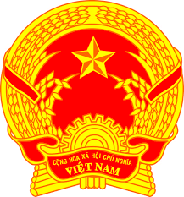
Statement of the Socialist Republic of Viet Nam
46th Session of the UPR Working Group
Review of Cambodia
(Geneva, 08 May 2024)

Mister President,
Viet Nam extends a warm welcome to the delegation of Cambodia.
We appreciate Cambodia’s continued efforts to enhance socio-economic development, eliminate poverty and raise people’s living standards. We also commend Cambodia’s efforts to advance gender equality and empower women socially and economically through various policies and action plans.
In a spirit of constructive dialogue, Viet Nam makes two recommendations to Cambodia:
First, continue to enhance its efforts and policies to improve access to work, particularly for young persons, women, people with disabilities and people living in rural areas.
Second, continue its efforts to expand access to healthcare services and health insurance system, aiming at the goal of universal health coverage.
Viet Nam wishes Cambodia every success with this UPR cycle.
Thank you, Mister President./.

