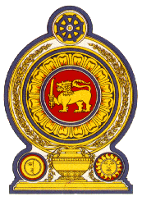

**46th Session of the Universal Periodic Review**

**Review of Cambodia**

**08 May 2024**

**Statement by the Democratic Socialist Republic of Sri Lanka**

Mr President,

Sri Lanka warmly welcomes the delegation of Cambodia and appreciates the presentation made.

We commend Cambodia’s constructive engagement with the UPR process and the progress made following the 3rd UPR cycle.

Sri Lanka welcomes the progressive, legislative and strategic measures introduced by Cambodia to promote women’s and children’s rights including the National Action Plan to Prevent Violence Against Women 2019-2023, National Policy for the Child Protection System and Action Plan to Prevent and Respond to Violence against Children.

In a constructive spirit, Sri Lanka recommends Cambodia:

* enhance legal protection for children against child labour.
* strengthen national efforts at combating trafficking in persons, including protection for victims of trafficking, in particular of women and children

We wish Cambodia every success in its UPR engagement.