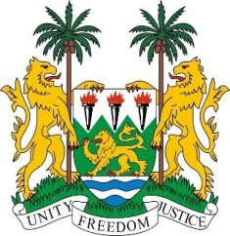

**SIERRA LEONE**

**46th Session of the UPR Statement**

**The Kingdom of Cambodia**

Wednesday, 8 May 2024

**Check against delivery.**

**Mr President,**

Sierra Leone welcomes the distinguished delegation of the Kingdom of Cambodia and thanks them for their presentation.

We commend the Royal Government for its continued engagement and cooperation with the Human Rights Council (HRC) and its mechanisms. Such engagement serves to promote, advance, and protect human rights within Cambodia.

We also commend the government for successfully implementing the first phase of its Pentagonal Strategy, which prioritises growth, employment, equity, efficiency and sustainability. These comprehensive policies will have a positive impact on the population, especially low-income and vulnerable groups, by promoting economic development and social inclusion.

 We welcome the Royal Government's decision to renew the Memorandum of Understanding (MoU) with OHCHR for a further two years, from 1 January 2023 to 31 December 2024. This renewal underscores the Cambodian government's unwavering commitment to upholding fundamental freedoms and democracy as enshrined in the Cambodian Constitution.

In a constructive spirit we recommend the following.

1.    Ensure refugees can effectively access pathways to Cambodian citizenship or to other forms of permanent status within the country to which they are entitled under the law.

2.    Continue its engagement and cooperation with human rights mechanisms and special procedures to uphold and promote human rights standards and principles in Cambodia.

3.    Ensure full implementation of the recently enacted Law on Civil Registration, Vital Statistics and Identification to ensure universal access to essential documentation and identity records.

Sierra Leone wishes Cambodia a successful fourth cycle review.

Thank you, **Mr President**.