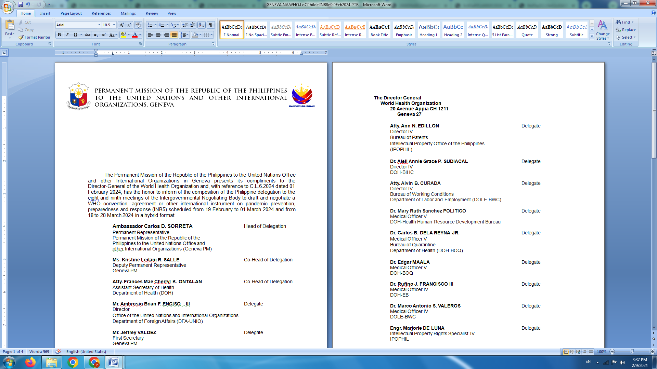

**P H I L I P P I N E S**

**HUMAN RIGHTS COUNCIL**

**46th Session of the Working Group on the Universal Periodic Review**

08 May 2024, Palais des Nations, Geneva, Switzerland

**UNIVERSAL PERIODIC REVIEW OF CAMBODIA**

*To be delivered by:*

**KRISTINE LEILANI R. SALLE**

**Deputy Permanent Representative**

*Speaking time: 1 minute 10 seconds*

Mr. President,

The Philippines warmly welcomes the delegation of Cambodia.

We laud the strides made by Cambodia in raising the living standards of its people, particularly in terms of access to education and health services. We particularly note the declining trend of maternal, infant, and child under-5 mortality rates as well as the expansion of school infrastructure across the country during the review period.

Cambodia’s longstanding constructive engagement with the OHCHR, other UN human rights mechanisms, and bilateral partners to further develop its human rights frameworks is likewise noteworthy.

We welcome Cambodia’s acknowledgment of the challenges and constraints it faces and the commitment to forge ahead with its human rights agenda.

In a constructive spirit, we recommend the following:

1. Continue to align domestic frameworks with international obligations and standards, including by expediting the establishment of a national human rights institution and judicial reforms;
2. Intensify the campaign to combat human trafficking for the purpose of forced labour and sexual exploitation, especially of women and girls;
3. Strengthen preventive and access to justice mechanisms in the fight against child labour.

We wish Cambodia all success in this review. **END**