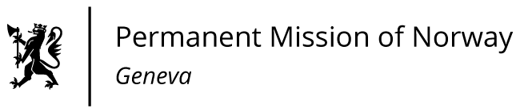

**STATEMENT**

**UPR 46 Session of the Human Rights Council**

**on the human rights situation in Cambodia,**

**as delivered by Mr. Martin Torbergsen**

**Minister Counsellor, Permanent Representative of Norway in Geneva.**

Check against delivery

8 May 2024

Vice President,

Norway welcomes Cambodia's delegation and thanks it for the presentation of its report. We welcome improvements made by Cambodia including with respect to women’s rights and gender equality, but we remain concerned about democratic development and limited political and civic space.

Norway recommends that Cambodia:

1. Ensures the right to freedom of expression, association and peaceful assembly and ends practices of arbitrary arrests and detention of human rights defenders, political opponents, trade unionists and journalists.
2. Restores civic space and creates the conditions for a genuine multiparty democracy including free and fair elections and ensures independent media.
3. Implements judicial reforms safeguarding the independence and impartiality of the court system, court personnel and judges, in accordance with international standards.

Thank you.