*Check against delivery*

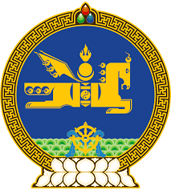

**46th SESSION OF THE UPR WORKING GROUP**

**MONGOLIA’S STATEMENT AT THE REVIEW OF CAMBODIA**

**8 May 2024, 09:00 - 12:00 hrs**

(1 min 10 sec)

Thank you, Mr. President.

Mongolia takes positive note of Cambodia’s efforts to cooperate with the UN human rights mechanisms.

In the spirit of constructive engagement, Mongolia recommends Cambodia to:

**One.** Strengthen the legislation and further enhance its efforts to fight trafficking in persons, including women and children and those in situations of forced labour, by taking victim protection and preventive measures;

**Two.** Expedite its process to adopt a comprehensive child protection law in line with the Convention on the Rights of the Child;

**Three.** Step up its efforts to address gender-based discrimination and violence, including domestic violence, against women and girls;

**Four.** Accelerate its process to establish an independent national human rights institution, in compliance with the Paris Principles.

I thank you.

---oOo---