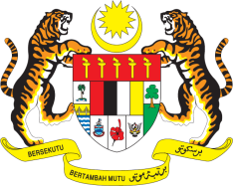

**STATEMENT BY MALAYSIA**

**REVIEW OF CAMBODIA**

**46TH SESSION OF THE UPR WORKING GROUP**

**29 APRIL – 10 MAY 2024**

Malaysia commends Cambodia for its constructive cooperation with the OHCHR in promoting human rights through technical cooperation programmes. We applaud Cambodia for taking numerous efforts to strengthen health, education, socio-economic development and poverty reduction in the country. On the regional front, Malaysia appreciates Cambodia’s important contribution to the ASEAN Community building and the realisation of the ASEAN common human rights agenda.

2. In the spirit of constructive engagement, Malaysia recommends the following:

2.1 First, continue to invest in programmes on poverty reduction, rural development, and infrastructure improvements to uplift living standards and promote inclusive growth in the country;

2.2 Second, strengthen efforts to promote economic and social development, including by creating more economic opportunities, improving essential services such as health care and education, and increasing participation in capacity building programmes offered by individual member states, regional and international community; and

2.3 Third, continue collaboration with various UN human rights mechanisms, particularly with the OHCHR.

3. We wish Cambodia a successful review.

Thank you.

**8 MAY 2024**

**GENEVA**