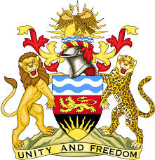

**REPUBLIC OF MALAWI**

**MALAWI STATEMENT ON CAMBODIA UNIVERSAL PERIODIC REVIEW**

**WEDNESDAY, 8TH MAY 2024**

**Mr. President**,

Malawi welcomes Cambodia to this review and thanks the delegation for the comprehensive presentation.

In the spirit of constructive dialogue, Malawi makes the following recommendations to Viet Nam:

1. Continue with efforts to fight discrimination against indigenous people and minorities.
2. Continue with reform measures being taken to improve the efficiency of the judiciary at all levels.
3. Continue taking all measures to combat trafficking in persons.

We wish Cambodia all the best at this review and in the implementation of the recommendations.

**Thank you, Mr. President**.