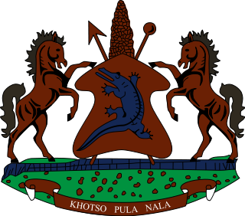

**INTERVENTION OF THE DELEGATION OF LESOTHO UNDER THE UPR REVIEW OF CAMBODIA**

**8 MAY 2024**

**GENEVA, SWITZERLAND**

**Thank you, Mr. President,**

Lesotho welcomes the distinguished delegation of Cambodia and recognizes the efforts to advance human rights in Cambodia since the previous UPR cycle. We highly appreciate Cambodia's official recognition of the interrelationship between press freedom and environmental crisis and the public acknowledgment of the media’s critical role in promoting the sustainable development of Cambodia.

In the light of the above, Lesotho believes there are areas where Cambodia can further enhance its human rights record, and therefore wishes to recommend as follows: 1. To accelerate efforts to mitigate incidents of excessive use of force and ill-treatment of detainees, by law enforcement agencies; 2. To beef up efforts to prevent violations of the rights to freedom of expression, association and peaceful assembly as guaranteed in the ICCPR; and lastly to bolster efforts to protect women’s rights, specifically through reform of the Law on Domestic Violence such that legislation is in line with the CEDAW and ICCPR recommendations.

Lesotho appreciates Cambodia's engagement with the UPR process and wishes the delegation every success in this cycle.

**Thank you.**