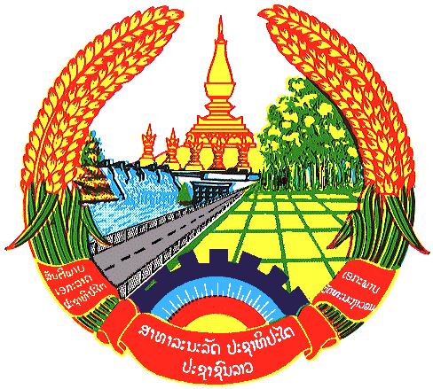

**Statement by the delegation of the Permanent Mission of the Lao PDR to the United Nations Office and other International Organizations in Geneva**

**at the 46th Session of UPR Working Group**

**Geneva, 8 May 2024**

(Speaking time 1.10 minute)

Review of Cambodia (09:00 – 12:30)

1. Thank you, Mr. President.
2. My delegation warmly welcomes and thanks Cambodia for the presentation of their national report.
3. The Lao PDR commends Cambodia for its remarkable achievements in poverty reduction, rural development and infrastructure improvement, which have contributed to advancing human rights and well-being of Cambodian people.
4. The Lao PDR recommends Cambodia the followings:

**ONE:** Strengthen efforts to improve the quality of education and the accessibility to education for all; and

**TWO:** Continue efforts to promote and protect the rights of persons with disabilities through the effective implementation of the national strategic plan on disability.

1. We wish Cambodia a successful UPR review.
2. I thank you, Mr. President.