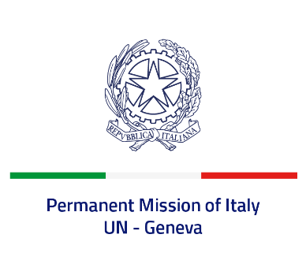

*Check against delivery*

**UPR 46 - Cambodia**

**Wednesday 8 May 2024, 9:00 - 12:30**

**Delivered by: Ambassador Vincenzo Grassi, Permanent Representative of Italy**

Thank you, Mister President.

We thank the distinguished delegation of Cambodia for the presentation.

Italy notes with appreciation Cambodia’s cooperation with United Nations human rights mechanisms, particularly with the Office of the High Commissioner for Human Rights.

Italy seizes this opportunity to offer Cambodia the following recommendations:

* *Guarantee the right to freedom of opinion and expression, as well as the right to freedom of assembly and association, in accordance with international obligations, to provide an enabling environment for journalists, human rights defenders and political activists;*
* *Continue to implement measures to ensure the independence of the judiciary and media;*
* *Step up efforts to fight against trafficking in persons, in particular women and children, and to combat forced labour and sexual exploitation;*
* *Consider adopting an adequate legal framework to recognize and protect the rights of Indigenous Peoples and ethnic minorities in relation to land and resources.*

We wish Cambodia a successful review.

I thank you.