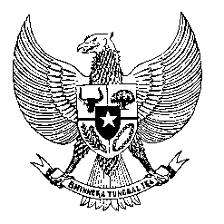

Permanent Mission
of the Republic of Indonesia to the UN, WTO,
and Other International Organizations
in Geneva

STATEMENT BY THE DELEGATION OF THE REPUBLIC OF INDONESIA
AT THE 46th SESSION OF THE UPR WORKING GROUP
CONSIDERATION OF THE UPR REPORT OF CAMBODIA
8 MAY 2024

Mr/Mdm Vice President,
Indonesia welcomes the esteemed delegation of Cambodia and thanks them for presenting their national report.

As a fellow ASEAN member state, we recognize Cambodia's active participation in ASEAN human rights mechanisms. We commend Cambodia for its achievements in enhancing human rights protection and fostering robust cooperation with various human rights mechanisms, including the OHCHR.

While acknowledging these efforts, Indonesia recommends the following:

- Improve access to quality healthcare and education, particularly in rural areas and among vulnerable groups, by reducing financial barriers to education and enhancing healthcare facilities.

- Intensify efforts to combat human trafficking through rigorous enforcement of relevant laws.

- Enhance endeavors to safeguard the rights of migrant workers within the sphere of labor rights.

Indonesia remains committed to supporting Cambodia and wishes for a successful UPR.

Thank you.

