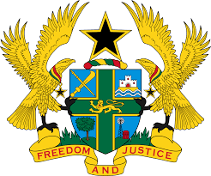

**STATEMENT DELIVERED BY GHANA DURING THE 46TH SESSION OF THE UNIVERSAL PERIODIC REVIEW WORKING GROUP ON WEDNESDAY 8TH MAY, 2024**

**UNIVERSAL PERIODIC REVIEW OF CAMBODIA**

Madam, Vice President.

2. Ghana warmly welcomes the delegation of Cambodia to the fourth UPR cycle.

3. We commend the strong commitments made by the Government of Cambodia to strengthen and accelerate the implementation of the National Action Plan on the reduction of child labour. We further applaud the launch of the National Disability Strategic Plan, which is a bold response to the commitment to protect and promote the rights of persons with disabilities.

4. In the spirit of constructive dialogue, Ghana recommend the following for Cambodia’s consideration:

1. **Ratify the Convention on the Protection of the Rights of all Migrant Workers and Members of their Families; and**
2. **Fast-track the establishment of an independent national human rights institution in consultation with relevant stakeholders.**

5. Ghana wishes Cambodia a successful review.

I thank you.