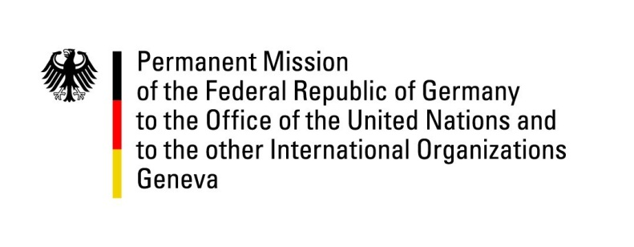

**United Nations Human Rights Council**

**46th Session of the UPR Working Group**

**Geneva, May 8, 2024**

**German Recommendations and advance questions to**

**Cambodia**

Mister President,

Germany welcomes the delegation of Cambodia and appreciates the government’s engagement in constructive dialogues with the LGBTIQ community as well as the inclusion of lesbian, bisexual and transgender persons in the National Action Plan to Prevent Violence Against Women.

However, Germany remains concerned about continued limitations and slow progress and improvement of working conditions for civil society.

Germany therefore recommends Cambodia to

1. take measures to ensure civic participation in political and public life without intimidation, especially with a view to limiting the use of strategic lawsuits against public participation;
2. enact legal amendments to recognize same-sex marriages as equal before the law, in order to achieve non-discrimination, full equality and social inclusion of LGBTIQ persons in Cambodia;
3. simplify union registration and reduce regulations that limit peaceful assembly and the right to strike and improve the protection of union leaders and workers.

Thank you, Mister President.

**Germany’s Advance Questions to Cambodia**

1. What measures has the government taken to implement the recommendations regarding same-sex marriage in the reporting period? What steps will be taken to overcome the existing obstacles in the next reporting period? Does the government monitor gender-sensitive aspects? Does the government review existing laws and policies to ensure the prevention of discrimination based on gender identity? Will the curricula of public schools include LGBTIQ-related content?
2. How many registrations for unions were filed in the reporting period? How many of these registrations were granted? How many were denied? What is the longest time the decision can take? Which measures has the government of Cambodia taken to reduce the number of denials in these cases and to speed up the process? How does the government support employees in asserting their statutory employment rights?
3. What does the government plan to do to prevent frivolous court procedures meant to discourage public participation? Have measures already been taken? If yes, which measures? Has the government taken any action on creating clear rules and laws on media registration and licensing in the reporting period? If not, why not and how is the government planning to make the licensing process more transparent and predictable?