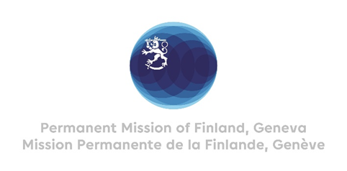

**46th Session of the UPR working group**

**Recommendations by Finland to Cambodia**

**8th May 2024**

Mr. President,

Finland welcomes the engagement of Cambodia in the UPR process. Finland positively notes that Cambodia hosted the Special Rapporteur on the situation of human rights in Cambodia last December.

Finland respectfully recommends:

1. One, to ensure freedom of expression, association and peaceful assembly for all, including representatives of political parties, journalists and media workers, labor groups, human rights defenders and civil society
2. Two, to cease harassment, intimidation, arbitrary arrest and unjust prosecution of political opposition, human rights defenders, journalists and media workers and labour activists,
3. Three, to ensure that fair trial guarantees, especially rights to access the outside world, family and lawyers, as provided in international law and standards are respected and upheld in all cases.

I thank you.